**4th Lab - Dynamic IP Address Allocation using DHCP in Multi-Network Topology**

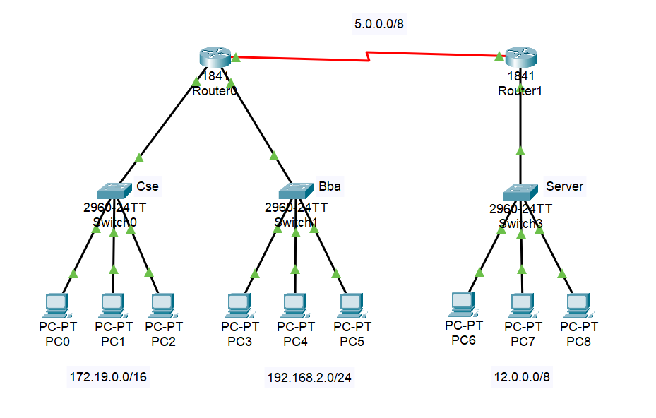**Topology:**

1. **Network Overview:**

|  |  |  |  |
| --- | --- | --- | --- |
| Device | Subnet | DHCP Pool Name | Connected PCs |
| Switch0 (IST) | 172.19.0.0/16 | Cse | PC0, PC1, PC2 |
| Switch1 (IST) | 192.168.2.0/24 | Bba | PC3, PC4, PC5 |
| Switch2 (ISP) | 12.0.0.0/8 | Server | PC6, PC7, PC8 |

1. **Router Configuration (CLI)**

**Router 0 (IST)**

Router> enable

Router# configure terminal

Router(config)# hostname IST

IST(config)# interface fastethernet 0/0

IST(config-if)# ip address 172.19.0.1 255.255.0.0

IST(config-if)# no shutdown

IST(config-if)# exit

IST(config)# interface fastethernet 0/1

IST(config-if)# ip address 192.168.2.1 255.255.255.0

IST(config-if)# no shutdown

IST(config-if)# exit

IST(config)# interface serial 0/0/0

IST(config-if)# ip address 5.0.0.1 255.0.0.0

IST(config-if)# no shutdown

IST(config-if)# clock rate 148000

IST(config-if)# exit

**! DHCP pool for 172.19.0.0/16 - Cse**

IST(config)# ip dhcp pool Cse

IST(dhcp-config)# network 172.19.0.0 255.255.0.0

IST(dhcp-config)# default-router 172.19.0.1

IST(dhcp-config)# exit

**! DHCP pool for 192.168.2.0/24 - Bba**

IST(config)# ip dhcp pool Bba

IST(dhcp-config)# network 192.168.2.0 255.255.255.0

IST(dhcp-config)# default-router 192.168.2.1

IST(dhcp-config)# exit

**! IP Route**

IST(config)# ip route 12.0.0.0 255.0.0.0 5.0.0.2

**! End and Save**

IST(config)# Ctrl + Z

IST# write

**Router 1 (ISP)**

Router> enable

Router# configure terminal

Router(config)# hostname ISP

ISP(config)# interface fastethernet 0/0

ISP(config-if)# ip address 12.0.0.1 255.0.0.0

ISP(config-if)# no shutdown

ISP(config-if)# exit

ISP(config)# interface serial 0/0/1

ISP(config-if)# ip address 5.0.0.2 255.0.0.0

ISP(config-if)# no shutdown

ISP(config-if)# exit

**! DHCP pool for 12.0.0.0/8 - Server**

ISP(config)# ip dhcp pool Server

ISP(dhcp-config)# network 12.0.0.0 255.0.0.0

ISP(dhcp-config)# default-router 12.0.0.1

ISP(dhcp-config)# exit

**! IP Route**

ISP(config)# ip route 172.19.0.0 255.255.0.0 5.0.0.1

ISP(config)# ip route 192.168.2.0 255.255.255.0 5.0.0.1

**! End and Save**

ISP(config)# Ctrl + Z

ISP# write

1. **PC Configuration Steps**
2. Click on PC (e.g., PC0)
3. Go to Desktop tab > IP Configuration
4. Select DHCP
5. An IP address, subnet mask and default gateway will be automatically assigned.